1) What is the most accurate relationship between a Luo-Connecting point and a Luo-Connecting Channel?
A) They are interchangeable names for the same point.
B) The point is the named origin; the channel is the pathway that leaves it. +++++
C) The channel always begins at a Jing-Well point.
D) The point belongs to an Extraordinary Vessel.
Feedback: A Luo point is the named origin of a Luo-Connecting Channel; the channel is the branch that travels from that point. Why are the other options incorrect? They are interchangeable names for the same point. — A point and the pathway arising from it are related but not interchangeable. The channel always begins at a Jing-Well point. — Luo routes are not defined by beginning at Jing-Well points. The point belongs to an Extraordinary Vessel. — Ordinary Luo points belong to Primary Channels, not automatically to Extraordinary Vessels.
2) Which Luo-Connecting pathway begins at LI-6 and continues toward the jaw, teeth and ear?
A) Large Intestine Luo-Connecting Channel +++++
B) Small Intestine Luo-Connecting Channel
C) Stomach Luo-Connecting Channel
D) Lung Luo-Connecting Channel
Feedback: The Large Intestine Luo-Connecting Channel begins at LI-6 and has a distinctive continuation toward the jaw, teeth and ear. Why are the other options incorrect? Small Intestine Luo-Connecting Channel — The Small Intestine Luo route begins at SI-7 and is associated with the shoulder. Stomach Luo-Connecting Channel — The Stomach Luo route begins at ST-40 and continues toward the nape, head and throat. Lung Luo-Connecting Channel — The Lung Luo route begins at LU-7 and continues toward the palm and thenar region.
3) Which Luo-Connecting pathway begins at ST-40 and continues toward the nape, head and throat?
A) Gall Bladder Luo-Connecting Channel
B) Stomach Luo-Connecting Channel +++++
C) Spleen Luo-Connecting Channel
D) Bladder Luo-Connecting Channel
Feedback: The Stomach Luo-Connecting Channel begins at ST-40 and is recognized by its continuation toward the nape, head and throat. Why are the other options incorrect? Gall Bladder Luo-Connecting Channel — The Gall Bladder Luo route begins at GB-37 and continues toward the dorsum of the foot. Spleen Luo-Connecting Channel — The Spleen Luo route begins at SP-4 and relates to the abdomen, Stomach and intestines. Bladder Luo-Connecting Channel — The Bladder Luo route begins at BL-58 and connects with the Kidney Channel.
4) Which distinctive region helps identify the Liver Luo-Connecting Channel from LIV-5?
A) The genital region +++++
B) The posterior shoulder
C) The nape and throat
D) The thenar eminence
Feedback: The Liver Luo-Connecting Channel from LIV-5 has a characteristic relationship with the genital region. Why are the other options incorrect? The posterior shoulder — The posterior shoulder is more characteristic of the SI-7 Luo continuation. The nape and throat — The nape and throat are characteristic of the ST-40 Luo route. The thenar eminence — The thenar eminence belongs to the LU-7 Luo continuation.
5) Which Luo-Connecting Channel begins at GB-37 and extends toward the dorsum of the foot?
A) Gall Bladder +++++
B) Kidney
C) Sanjiao
D) Liver
Feedback: The Gall Bladder Luo-Connecting Channel begins at GB-37 and continues across the dorsum of the foot. Why are the other options incorrect? Kidney — The Kidney Luo begins at KID-4 and relates to the perineum and lumbar region. Sanjiao — The Sanjiao Luo begins at SJ-5 and has posterior-arm and chest relationships. Liver — The Liver Luo begins at LIV-5 and relates characteristically to the genital region.
6) Which Luo-Connecting Channel begins at HT-5 and has branches related to the root of the tongue and eye?
A) Heart +++++
B) Pericardium
C) Small Intestine
D) Lung
Feedback: The Heart Luo-Connecting Channel begins at HT-5 and has characteristic relationships with the Heart, tongue root and eye. Why are the other options incorrect? Pericardium — The Pericardium Luo begins at PC-6 and connects with the Sanjiao while entering the chest. Small Intestine — The Small Intestine Luo begins at SI-7 and continues toward the shoulder. Lung — The Lung Luo begins at LU-7 and continues to the palm and thenar eminence.
7) Which origin and continuation correctly describe the Kidney Luo-Connecting Channel?
A) KID-4; perineum and lumbar region +++++
B) KID-3; jaw and teeth
C) KID-6; lateral heel and eye
D) KID-10; shoulder and scapula
Feedback: The Kidney Luo-Connecting Channel begins at KID-4 and has characteristic perineal and lumbar continuations. Why are the other options incorrect? KID-3; jaw and teeth — Jaw and teeth characterize the LI-6 Luo route, not a KID-3 route. KID-6; lateral heel and eye — The lateral heel-to-eye course describes Yang Qiao Mai, not a Kidney Luo route. KID-10; shoulder and scapula — The shoulder continuation is associated with SI-7 rather than KID-10.
8) Which special Luo pathway spreads across the lateral chest from SP-21?
A) Great Luo of the Spleen +++++
B) Governing Vessel Luo
C) Dai Mai
D) Bladder Divergent Channel
Feedback: The Great Luo of the Spleen arises from SP-21 and spreads broadly across the lateral chest. Why are the other options incorrect? Governing Vessel Luo — The Governing Vessel Luo follows a posterior midline/back relationship. Dai Mai — Dai Mai girdles the waist and is an Extraordinary Vessel. Bladder Divergent Channel — The Bladder Divergent is a deep paired-organ pathway, not a special Luo from SP-21.
9) What is the channel shown in the image?
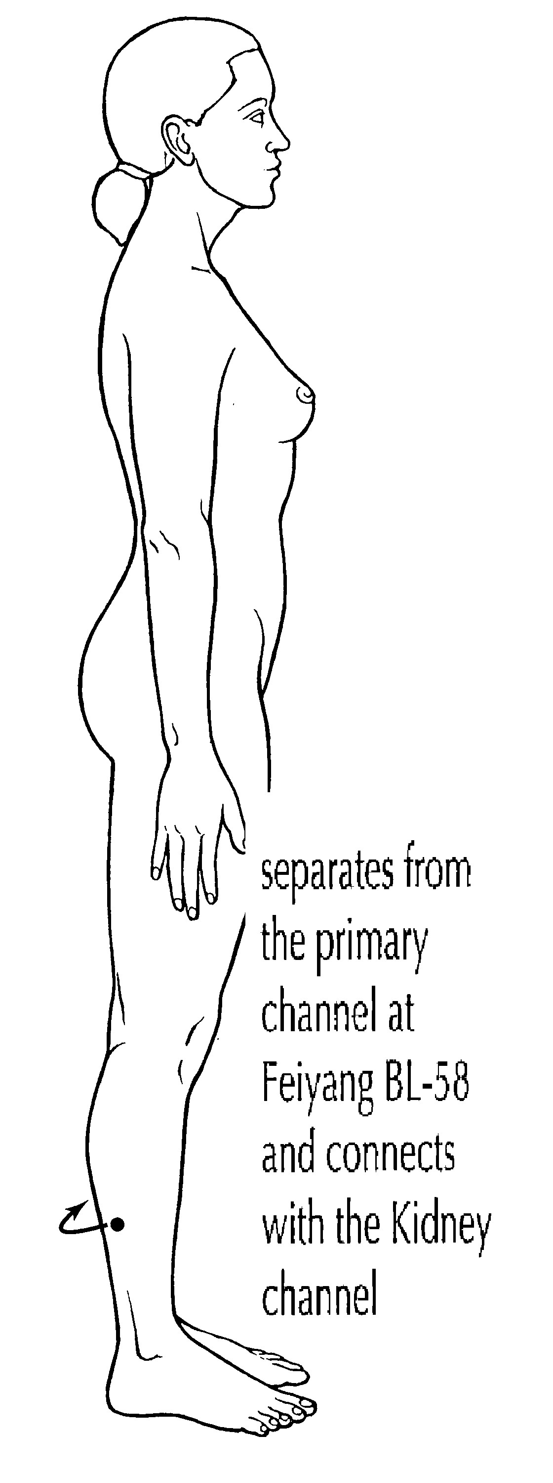
A) Bladder Luo-Connecting Channel +++++
B) Bladder Divergent Channel
C) Bladder Sinew Channel
D) Bladder Primary Channel
Feedback: The image shows a short branch leaving the Bladder Primary Channel at BL-58 on the posterolateral lower leg and connecting with the paired Kidney Channel, which identifies the Bladder Luo-Connecting Channel. Why are the other options incorrect? Bladder Divergent Channel — The Divergent Channel is a deep separation-and-convergence pathway. Bladder Sinew Channel — The Sinew Channel is a broad superficial musculotendinous chain. Bladder Primary Channel — The Primary Channel is the complete point-bearing posterior route.
10) What is the channel shown in the image?
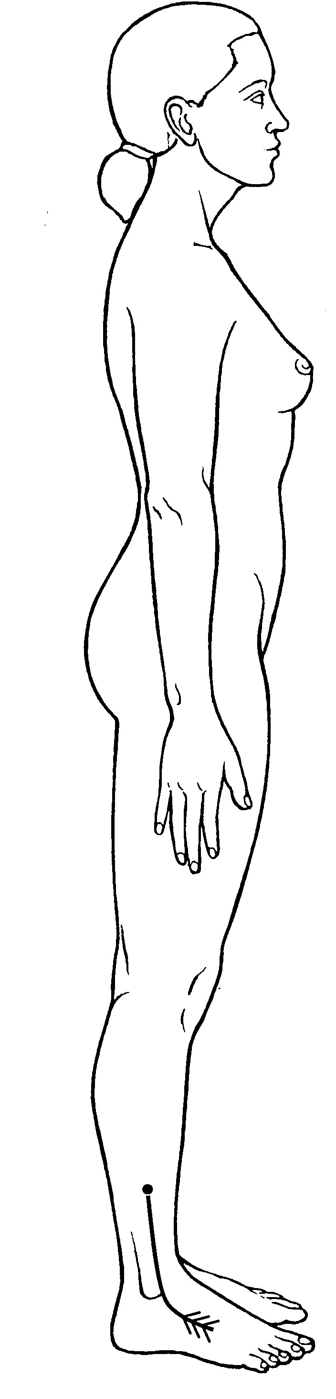
A) Gall Bladder Luo-Connecting Channel +++++
B) Gall Bladder Divergent Channel
C) Gall Bladder Sinew Channel
D) Gall Bladder Primary Channel
Feedback: The Gall Bladder Luo-Connecting Channel begins at GB-37 on the lateral lower leg, travels toward the dorsum of the foot and great toe region and connects with the paired Liver Channel. Why are the other options incorrect? Gall Bladder Divergent Channel — The Divergent Channel enters deeply and converges with the paired Liver pathway. Gall Bladder Sinew Channel — The Sinew Channel is a broad superficial lateral chain with binding regions. Gall Bladder Primary Channel — The Primary Channel is the complete point-bearing lateral pathway.

